 | PANCAP Coordinating Unit  CARICOM Secretariat  Tel:592-222-0001 | Fax:592-222-0203  www.pancap.org

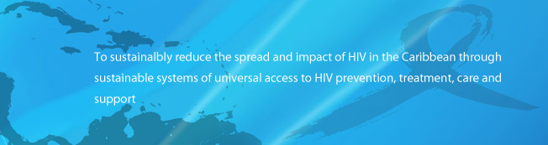
Week ending Friday, 30 March 2012

Around the region  Trade unions advocate for rights of HIV/AIDS workers  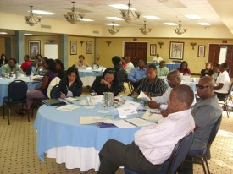  ST JOHN’S, Antigua – President of the Caribbean Congress of Labour (CCL), Senator David Massiah is urging trade unions to lead the fight against discrimination and stigma associated with people infected or affected by HIV/AIDS in the workplace.  “We think it is a problem that you have to look at and address early, sensitise the people as a matter of prevention so it doesn’t become a pandemic, where people begin to discriminate,” Massiah said.  Massiah acknowledged that although trade unions in Antigua & Barbuda have initiated the process in the past, continuity has been an issue.Read More  Network walks to stop HIV/AIDS  ST JOHN’S, Antigua – Scores of walkers turned out Saturday to lend support to the third annual Antigua & Barbuda HIV/AIDS Network’s (ABHAN) AIDS Walk, under the theme “Stop AIDS. Start Walking.”  Over 150 persons joined the effort to bring awareness to the issues of HIV/AIDS in Antigua & Barbuda, as well as to raise monies to fund ABHAN’s initiatives.Read More  Around the world  New Study Shows D.C. Female Condom Program Highly Effective in Preventing HIV Infections  Great news! Yesterday, a new study conducted by the Johns Hopkins Bloomberg School of Public Health showed that the female condom program in Washington, D.C., is highly effective in preventing HIV infection. These findings are cause for excitement as they affirm the importance of female condoms in preventing HIV and other STIs and unintended pregnancies in the U.S. and around the world. We know that investing in female condoms is the right thing to do and now we have additional data to continue to make the case for female condoms as a cost effective prevention intervention.Read More  More evidence and better diagnostics needed before redefining severe forms of drug-resistant TB says WHO  Geneva - Reports of tuberculosis (TB) cases with severe patterns of drug resistance are increasing, said experts who attended a WHO meeting in Geneva on 21-22 March. Participants stressed that the emergence of drug resistance should be a wake-up call for Ministries of Health. The group urged the global TB community to make greater efforts to prevent drug resistance and scale up provision of appropriate care and management to avoid a scenario where TB becomes incurable. Read More  General Manager Discusses Global Fund Reorganisation  'It is difficult to find investments that give a return higher than those made in health'  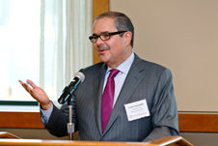  El Mundo 03/26/2012  Just seven weeks have passed since Gabriel Jaramillo, former Chief Executive of Sovereign Bank, took over as General Manager of the Global Fund to Fight AIDS, Tuberculosis and Malaria, and the transformation of this organization has already begun.  The aim of Jaramillo, with over 35 years experience in the field of finance, is to transform the Fund into a more efficient organization that meets the control requirements expressed by the donor countries, fueled by the crisis and fraud detected in 2011.Read More  New US treatment guidelines recommend antiretroviral treatment for all people with HIV  Newly updated US antiretroviral treatment guidelines are recommending antiretroviral treatment for all people with HIV infection, with particular emphasis on treatment for: people with CD4 cell counts below 500; anyone at risk of transmitting HIV to partners; pregnant women; and people with hepatitis B co-infection or HIV-related kidney disease.Read More  Early infant diagnosis for HIV: is it taking place early enough?  Current early infant diagnosis (EID) protocols may need to be revised in the light of current WHO guidelines on the prevention and treatment of HIV-infection in low-resourced settings, according to Dr. Gayle Sherman of Wits University, South Africa, and senior specialist in Paediatric Haematology with the country's National Health Laboratory Services, speaking at the 19th Conference on Retroviruses and Opportunistic Infections held last week in Seattle.Read More  Serosorting does help prevent HIV – up to a point  A meta-analysis of HIV-negative gay men’s sexual behaviour and HIV incidence rate in four HIV prevention studies, presented earlier this month at the 19th Conference on Retroviruses and Opportunistic Infections (CROI), has found that attempting to ‘serosort’ by restricting unprotected sex to partners known to be HIV negative does have efficacy as an HIV prevention strategy, when compared with using no strategy at all.Read More
  Recently uploaded ...
  
  PCU Director on Issues of Sexuality
  Ms Juliette Bynoe Sutherland speaks to youth of the University of Guyana on the occasion of International Womens Day , 2012, Ms Sutherland is a Gender Avvoacate for the Caribbean Coalition on Women and Girls/ UN Women.
  View here and be sure to leave your comments...
  Activities for the coming week...
  16-17 April 2012 – The Technical Working Group (TWG) Meeting of the HIV Prevention Task Force will meet at the CARICOM Secretariat Headquarters in Georgetown, Guyana. The main objectives of the meeting are to review the characteristics of the current prevention response. The meeting will also discuss practical recommendations for moving the prevention response forward to meet the Millennium Development Goals (MDGs) by 2015. Discussions will also take place on how the TWG will support the PCU’s work with member countries to improve human and institutional capacity to manage and deliver creative, innovative HIV prevention programmes. Membership of the TWG is drawn from partner agencies, National AIDS Programmes and civil society. For further information, please contact Ms. Valerie Beach-Horne at vbeachhorne@caricom.org
  see other events here

You are receiving this email because you subscribed for our newsletter. To stop receiving it please Unsubscribe
Having trouble reading this email? View it in your browser.

